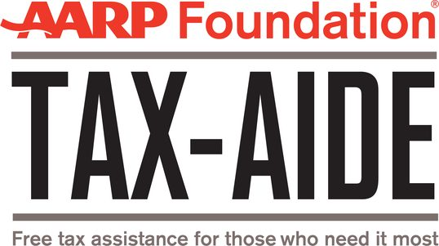
Get Your Taxes Done for Free
AARP Foundation Tax-Aide Provides In-Person Tax Preparation Services in Allegheny and Washington Counties
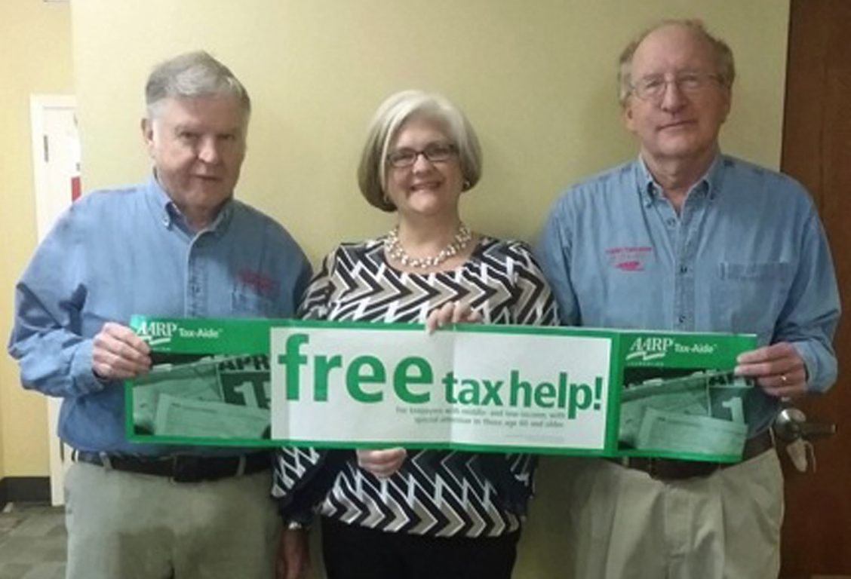
Visit TaxAide-Pittsburgh.com for More Information

January 12, 2023
Pittsburgh, PA — Beginning February 1st and continuing through April 16th, AARP Foundation is providing tax assistance and preparation in Allegheny and Washington Counties through its Tax-Aide program — and it’s completely free.

AARP Foundation Tax-Aide is the nation’s largest nationwide volunteer-based free tax preparation service. In 2020, 1.5 million taxpayers who used AARP Foundation Tax-Aide received more than $1 billion in income tax refunds.
Volunteers are trained and IRS-certified every year to ensure they understand the latest changes to the U.S. and Pennsylvania Tax Code. We can e-file your individual Federal, Pennsylvania and local EIT income tax returns, and your Pennsylvania Rent Rebate/Property Tax return. We make sure you claim the tax refund, credits, and deductions you have earned.

Please see our list of sites, schedules and telephone contact information for 2023, below. For several sites, appointments can be made online. More information, including an update on important tax code changes affecting your 2022 tax return, can be found at our website: taxaide-pittsburgh.com.

The most important tax code change affecting individuals is that the Enhanced Child Tax Credit, enacted during the pandemic, was not extended to 2022. This may result in a lower Federal refund for families with children. On the plus side, Pennsylvania added a Child Tax Credit modeled after the Federal credit, which may increase your Pennsylvania refund.

As in pre-pandemic years, your return will be prepared during one visit by appointment only, generally lasting 75 minutes. We cannot accommodate walk-ins. Some clients may require a second appointment on a different day.

For more information about AARP Foundation Tax-Aide, including what type of service is available where, and which documents you need to file your taxes, visit taxaide-pittsburgh.com or aarpfoundation.org/taxaide, or call 1-888-AARPNOW (1-888-227-7669).

Contact:
Stephen Cohen, 412-421-3999 (Allegheny County)
Rae Groy, 724-348-4403 (Washington County)
District Coordinators

About AARP Foundation
AARP Foundation works to end senior poverty by helping vulnerable older adults build economic opportunity and social connectedness. As AARP’s charitable affiliate, we serve AARP members and nonmembers alike. Bolstered by vigorous legal advocacy, we spark bold, innovative solutions that foster resilience, strengthen communities and restore hope. To learn more about AARP Foundation visit aarpfoundation.org.

WHAT TO BRING
- Please arrive 5-15 minutes early to complete a required eight-page Interview Form.
- Photo ID (REQUIRED).
- Social Security Cards or comparable documentation for you, your and all dependents spouse (if applicable).
- Income related documents: Forms W2, Unemployment compensation statements, SSA 1099, 1099R, other 1099 forms and any other relevant tax documents.
- Expense related documents: Checks and forms showing federal and state taxes paid, 1098 forms, documentation of medical, dental, charity, or business expenses, any vehicle and property taxes, and mortgage interest paid - IF YOU EXPECT TO ITEMIZE. Receipts for expenses need to be in reasonable order and legible.
- Brokerage statements or other documentation showing the cost basis (purchase price) and date purchased for all securities or property sold or transferred.
- Health insurance information: If you purchased Health Insurance in the Marketplace, you must bring Form 1095-A.
- If you are divorced, you must provide the date the divorce became final.
- If you receive a pension/annuity, please bring the date payments began.
- A check with your name printed on it for direct deposit/debit of any refund/balance due or a Bank Card showing your savings account and routing number. A check in your checkbook is acceptable. We simply need to SEE the check or Bank Card. It will be returned to you.

AARP FOUNDATION TAX-AIDE PROGRAM
ALLEGHENY COUNTY SITES FEBRUARY 1, 2021 THRU APRIL 16, 2022 - BY APPOINTMENT ONLY
MORE INFORMATION AT WWW.TAXAIDE-PITTSBURGH.COM OR WWW.AARP.ORG/FINDTAXHELP

ALLEGHENY COUNTY - EAST
LOCATION | OPERATION | CONTACT
CARNEGIE LIBRARY OF SQUIRREL HILL  5801 FORBES AVENUE  PITTSBURGH, PA 15213 | MONDAY & WEDNESDAY  12:00 – 4:00 PM  SATURDAY 10:00 AM – 4:00 PM  FEBRUARY 2 – APRIL 16 | Direct Appointments: taxaide-pittsburgh.com  Or call 412-530-5194  (NO CONTACT AT LIBRARY)
RECLAMATION CHURCH - MONROEVILLE  285 ST MARTIN'S DRIVE  MONROEVILLE, PA 15146 | TUESDAY & THURSDAY  9:15 – 4:00 PM  FEBRUARY 1 – APRIL 14 | STAFF  412-357-8941  (NO CONTACT AT CHURCH)
PLUM SENIOR CENTER  499 CENTER NEW TEXAS RD  PITTSBURGH, PA 15239 | TUESDAY & FRIDAY  9:00 – 3:00 PM  FEBRUARY 4 – APRIL 12 | STAFF  412-795-2330
CC MELLOR PUBLIC LIBRARY (EDGEWOOD)  1 PENNWOOD AVE #2,  PITTSBURGH, PA 15218 | TUES./WED./THURS.  10:00 – 3:30 PM  FEBRUARY 1 – MARCH 31 | STAFF  412-731-0909
CARNEGIE LIBRARY OF HOMESTEAD  510 E 10TH AVE,  MUNHALL, PA 15120 | TUESDAY & THURSDAY  12:00 – 4:00 PM  FEBRUARY 8 – APRIL 14 | STAFF (412) 462-3444
ALLEGHENY COUNTY - NORTH
STATE REP. DAN DEASY OFFICE  436 S MAIN STREET  PITTSBURGH, PA 15220 | MONDAY THRU THURSDAY  10:00 – 3:00 PM  FEBRUARY 14 – APRIL 12 | STAFF  412-928-9514
SHALER UNDERCLIFF VFD  700 MT. ROYAL BLVD  PITTSBURGH, PA 15223-1208 | MONDAY AND WEDNESDAY  9:00 AM – 1:00 PM  FEBRUARY 7 – APRIL 14 | ST. SEN. LINDSEY WILLIAMS  412-364-0469  (NO CONTACT AT FIRE HALL)
ROSS MUNICIPAL BUILDING  1000 ROSS MUNICIPAL DRIVE,  PITTSBURGH, PA 15237 | TUESDAY & THURSDAY  FEBRUARY 1 – APRIL 14  9:00 AM – 2:00 PM | ST. SEN. LINDSEY WILLIAMS  412-364-0469  (NO CONTACT AT CENTER)
COOPER-SIEGEL LIBRARY  403 FOX CHAPEL ROAD  PITTSBURGH, PA 15238-2225 | MONDAY & WEDNESDAY  FEBRUARY 7 – APRIL 13  9:00 AM – 2:00 PM | STAFF  412-828-9520 X 15
CHARTEIRS SENIOR CENTER  300 LINCOLN AVENUE  CARNEGIE, PA 15106-2902 | MONDAY & TUESDAY  FEBRUARY 1 – APRIL 5  9:00 AM – 1:00 PM | STAFF  412-276-5056
STATE REP. ROB MECURI 5500 BROOKTREE RD STE 100 WEXFORD, PA 15090 | TUESDAY & THURSDAY FEBRUARY 15 – APRIL 12  10:00 AM – 2:00 PM | STAFF 412-369-2230

MORE INFORMATION AT WWW.TAXAIDE-PITTSBURGH.COM OR WWW.AARP.ORG/FINDTAXHELP

