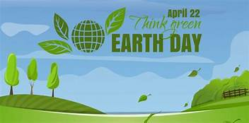
Great Reads for Earth Day!
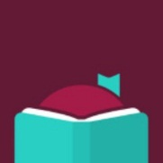
You can find all of these titles on Libby (Overdrive), our eBook platform.

No One is Too Small to Make a Difference by Greta Thunberg
https://libbyapp.com/library/acla/search/query-environment/subject-111/page-1/4966708
Libby app for eBooks

Invisible Nature by Kenneth Worthy
https://libbyapp.com/library/acla/search/query-environment/subject-111/page-1/1233696

Welcome to Your World by Sarah Williams Goldhagen
https://libbyapp.com/library/acla/search/query-environment/subject-111/page-1/2875703

The Nature Fix by Florence Williams
https://libbyapp.com/library/acla/search/query-environment/subject-111/page-1/3136117

Building a Better World in Your Backyard by Paul Wheaton & Shawn Klassen-Koop
https://libbyapp.com/library/acla/search/query-environment/subject-111/page-1/5029363

On a Farther Shore: The Life and Legacy of Rachel Carson by William Souder
https://libbyapp.com/library/acla/search/query-environment/subject-111/page-1/984589

For Young People…
On our Nature Walk Read-Along by Jillian Roberts
https://libbyapp.com/library/acla/search/query-environment/audience-1/page-1/5358114

These Rocks Count! by Alison Formento
https://libbyapp.com/library/acla/search/query-environment/audience-1/page-1/1584270

What Matters by Alison Hughes
https://libbyapp.com/library/acla/search/query-environment/audience-1/page-1/2877199

It’s Your World by Chelsea Clinton
https://libbyapp.com/library/acla/search/query-environment/audience-1/page-1/2232464

A Leaf Can Be by Laura Purdie Salas
https://libbyapp.com/library/acla/search/query-environment/audience-1/page-1/717279

Rachel Carson by Kathleen V. Kudlinkski
https://libbyapp.com/library/acla/search/query-environment/audience-1/page-1/303992

