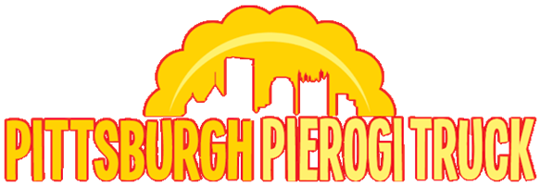
Fundraiser Order Sheet

$9/package 12/pkg*
NAME | PHONE NUMBER | EMAIL ADDRESS

Potato  &  Cheese | Potato  &  Onion | Potato  &  Cheddar | Potato  &  Bacon | Sauerkraut | Sauerkraut  &  Mushroom | Beef  *(10/pkg) | Cabbage | Sweet  Cheese | Total  Orders | Total  Amount  Due

Fundraiser Order Sheet
$9/package 12/pkg*
NAME | PHONE NUMBER | EMAIL ADDRESS

Potato  &  Cheese | Potato  &  Onion | Potato  &  Cheddar | Potato  &  Bacon | Sauerkraut | Sauerkraut  &  Mushroom | Beef  *(10/pkg) | Cabbage | Sweet  Cheese | Total  Orders | Total  Amount  Due
PLEASE MAKE YOUR SELECTION FROM THE FOLLOWING:
(ORDER FORM ON REVERSE SIDE)
Potato and Cheese: Made of all natural mashed potatoes and creamy cheese with no fillers.
Potato and Onion: Made with natural mashed potatoes and grated onion.
Potato and Cheddar: Made with fresh potatoes and cheddar cheese.
Potato and Bacon: This pierogi consists of our premium mashed potato filling mixed with bits of real bacon.
Sauerkraut: Finely chopped sauerkraut with a hint of carrot and onion.
Sauerkraut and Mushroom: Made of an earthy combination of sauerkraut and black mushrooms.
Beef: Made of tender finely shredded beef. 10/pkg
Cabbage: Made with a sweet sautéed cabbage filling.
Sweet Cheese: Made of creamy farmers cheese with a hint of sweetness and orange peel.

PLEASE MAKE YOUR SELECTION FROM THE FOLLOWING:
(ORDER FORM ON REVERSE SIDE)
Potato and Cheese: Made of all natural mashed potatoes and creamy cheese with no fillers.
Potato and Onion: Made with natural mashed potatoes and grated onion.
Potato and Cheddar: Made with fresh potatoes and cheddar cheese.
Potato and Bacon: This pierogi consists of our premium mashed potato filling mixed with bits of real bacon.
Sauerkraut: Finely chopped sauerkraut with a hint of carrot and onion.
Sauerkraut and Mushroom: Made of an earthy combination of sauerkraut and black mushrooms.
Beef: Made of tender finely shredded beef. 10/pkg
Cabbage: Made with a sweet sautéed cabbage filling.
Sweet Cheese: Made of creamy farmers cheese with a hint of sweetness and orange peel.

